**API End Points and Communication**

**Day 12: 20 March 28**

**Web Service:** Giving the service for web application when both the application running using different technologies.

Amazon --🡪 Spring boot

Payment

Credit card

Paypal asp.net

Paytm node js

Gpay python

PhonePay go

Web Service is plat form independent, language independent as well as browser independent.

App1 XML/JSON App2

Java python

XML :eXtensible Mark up language

JSON : JavaScript Object notation.

2 types

1. SOAP Web Service : Simple Object Access Protocol. Using SOAP Web Service we can consume as well as produce the data in the form of XML.

In SOAP Web Service we need to consume as well as produce data only in the form of XML.

SOAP request and response structure.

1. Rest Full Web Service : in Rest full web service we can consume and produce data in any format base upon client requirement. Like xml, json, plain text, html, or any other media type etc.

Representation state transfer. Using Rest API we can expose our Server side resources like servlet or jsp or spring controller as web service.

If we use normal controller

Servlet -🡪 then view must be html or jsp.

Spring controller using @Controller annotation -🡪 then view must be JSP or html or Thymeleaf as view.

JSP or Thymeleaf are java view technologies.

@RestController then view technologies can be any application like

Python, asp.net, java, angular or react js application can call our rest api.

**Creating basic rest api using spring boot**

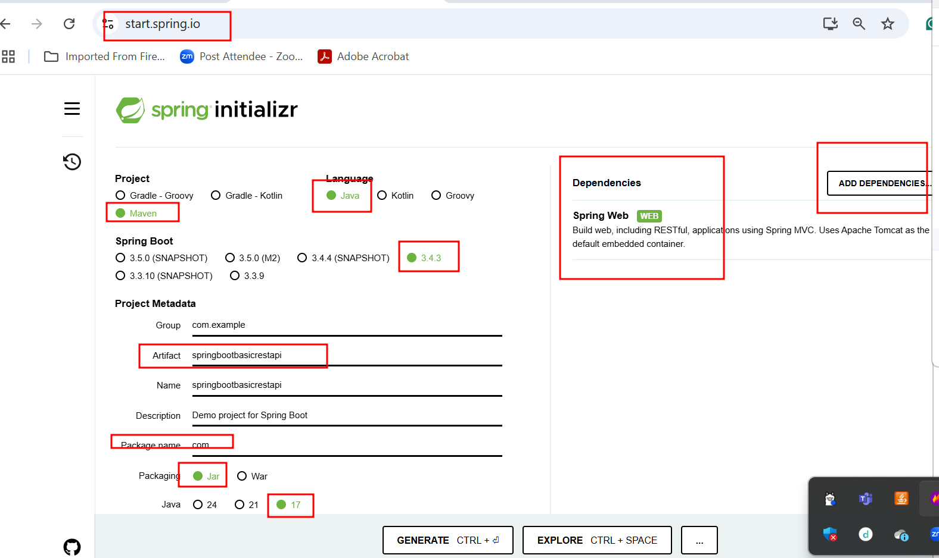

Rest API

Get methods : retrieve the data hard coding or from db.

1. Return string with different format like plain text, html, xml etc.
2. Return object with JSON or XML.

Using get method we can pass the value to rest api

1. Query param

URL?key=value single value

URL?key1=value1&key2=value2 multiple value

1. Path param

URL/value1 single value

URL/value1/value2 multiple value

Post methods

Put methods

Patch methods

Delete methods